|  |
| --- |
| Brigham Young University - Idaho |
| ECEN 250 – Lab 7 |
| Buffer – Assemble, Troubleshoot, Evaluate Performance, and Lab Equipment.docx |
|  |
|  |
| **9/29/2023** |

Table of Contents

Objectives 3

Principles to Be Studied 3

Background 3

Design Specifications 3

Procedures 4

Learn how to use lab equipment 4

Learn about Potentiometers 4

Solder and Test 4

Troubleshooting 10

Pass Off 11

Lab Report 12

# Objectives

The objective of this laboratory is to solder the components on the Buffer amplifier, troubleshoot any problems, and validate that it meets the design specifications. You will be introduced to soldering and using lab equipment, such as the function generator and the oscilloscope. Also, how to connect to and take measurements on the stereo amplifier.

# Principles to Be Studied

* Terms used in design specifications.
* Voltage dividers and variable resistors
* Parallel and series resistance
* Audio (logarithmic) and linear taper potentiometers
* Basic inverting amplifier op-amp gain design
* Op-amp virtual short characteristics and input impedance
* Thevenin equivalents
* Signal clipping

# Background

High quality stereo amplifiers have a very high input impedance (typically $1\text{M}Ω-20\text{M}Ω$). This high impedance reduces loading the signal source output stage. Driving the volume control directly with the line-in signal source is a low-quality design. Secondly, we would like to boost the signal slightly for our internal processing so that we have plenty of signal strength to drive the final amplifier stage to full output level. Lastly, what is a stereo without volume and balance controls?

# Design Specifications

**Volume Control**

* Dual channel, single control tracking
* Less than $1\text{dB}$ in tracking variation between left and right channels

**Balance Control**

* Dual channel, single control inverse tracking

**Line Buffer Amplifier**

* Input impedance $Z_{in}≥10 \text{k}Ω$
* Voltage gain ($A$): $-3$, nominal. That is, ${\left|A\right|}_{db}=20\log{|-3|}=9.5 \text{dB}$ nominally.
* Frequency response: $\left|{\left|A\left(f\right)\right|}_{\text{dB}}-9.5 \text{dB}\right|≤3 \text{dB}$ where $20 \text{Hz}≤f≤20 \text{kHz}$
$V_{in\left(max\right)}=8 V_{pp}$

* Power supply: $±14V_{DC}$

# Procedures

## Learn how to use lab equipment

* Watch Lab Equipment Introduction Videos
  + [Video: Setup to test the Buffer PCB - Left Channel](https://content.byui.edu/items/c92c83b7-f452-45e8-88e8-af32c4c64984/1/Lab3_SetupToTestBufferLeftChannel.mp4)
  + [Video: Function Generator Introduction](https://content.byui.edu/items/17875615-8588-4207-bc8a-7fe25568cb64/1/Function%20Generator%20Intruduction%20-%20ECEN250.mp4)
  + [Video: Oscilloscope Introduction](https://content.byui.edu/items/ed057fa3-64bf-4837-8473-ae3e9e0daa45/1/Oscilloscope%20Intruduction%20-%20ECEN250.mp4)
  + (Optional, not used in this lab): [Video: Power Supply Introduction](https://content.byui.edu/items/1ac2bf8b-e2d0-497e-99e3-831063247a3f/1/Power%20Supply%20Intruduction%20-%20ECEN250.mp4)

## Learn about Potentiometers

Do a little research on potentiometers. Specifically, define the following words: terminal, wiper, taper, dual-gang pot, linear taper, and logarithmic (or audio) taper. Why are logarithmic pots used for volume rather than linear pots? Why would linear pots work better for balance than for logarithmic pots? From your research, it should follow that regardless of the shaft angle, the resistance between the outmost terminals of the potentiometer should be constant.

# Solder and Test

With an acceptable simulation completed in Lab 2, you are now ready to solder the components to the PCB. Make sure you orient the op amp IC on the cell (or footprint) correctly. The side of the op-amp IC with pin 1 is more slanted than the other side, as shown in the datasheet (Pg 21 <http://www.ti.com/lit/ds/symlink/lf347-n.pdf?ts=1588261902101> also see below). If your still confused, ask a Lab Assistant.

If you have not already done so, watch the following to learn the basics of soldering:

* Core: [Soldering Components on Buffer PCB Video Demo.](https://byui.instructure.com/courses/182778/pages/byu-idaho-soldering-videos?module_item_id=25137604)
* Core: [Microscope Setup Video Tutorial](https://www.youtube.com/watch?v=KI3w3D-GEjo)
* Reference: [Complete set of IPC Soldering Training Videos](https://emp.byui.edu/smithk/labtutorials/IPC_Soldering_videos_tests_transcripts_reviews/)

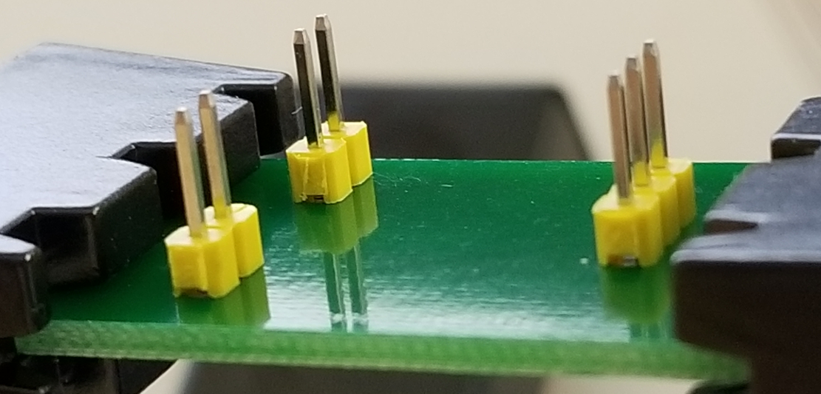

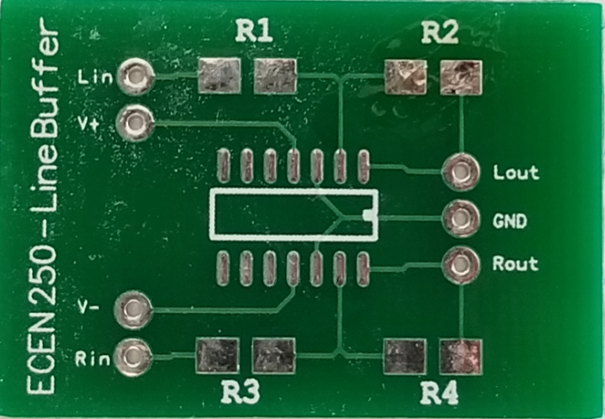

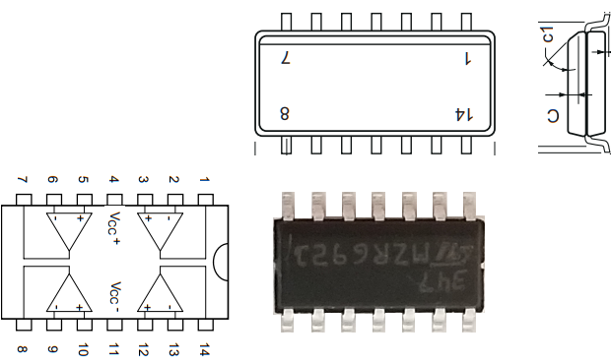

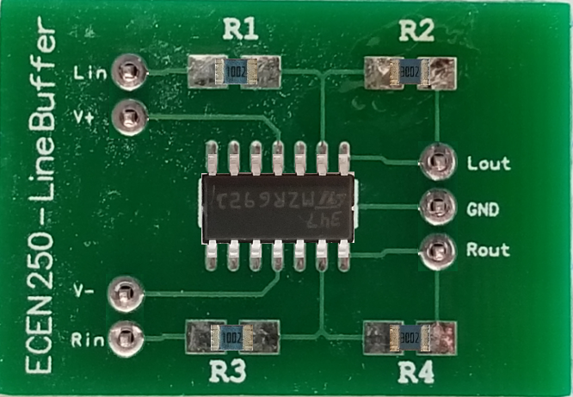

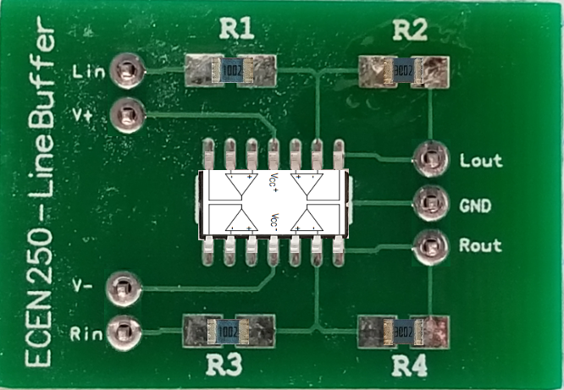

You may now insert your board into the Line Buffer slot of the chassis. You can power the board by plugging in the power chord into the chassis and into an outlet. Be careful not to shock yourself when plugging the power cord into the chassis, as the wires may be exposed on the inside of the chassis.

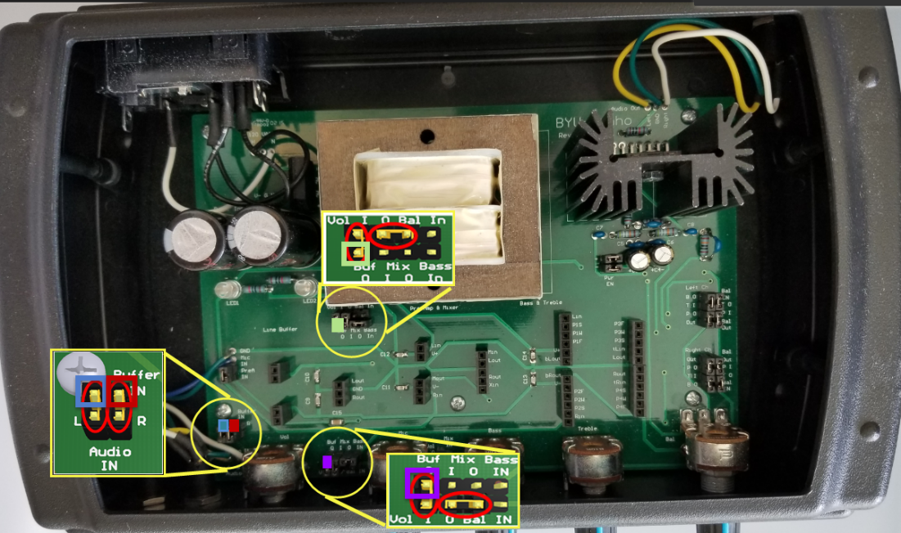

To test this board while it is plugged into the motherboard, use the left or right Buffer In pin for the input signal shown in the bottom left circle above and the Buf O (Left = top, Right = bottom) as the output show in the two circles just to the right. Then use the function generator as your input signal and connect the output to the oscilloscope as explained below.

Before you hook up your music source and the speakers to your circuit, test your circuit with an input signal from a function generator.

The following video will show the basics for connecting the function generator and the oscilloscope to the buffer PCB in the audio amplifier chassis ([Buffer PCB Test Setup](https://content.byui.edu/items/c92c83b7-f452-45e8-88e8-af32c4c64984/1/Lab3_SetupToTestBufferLeftChannel.mp4)).

Your “in-circuit” tests should emulate the simulations performed in PADS Pro Designer completed in Lab 2. Create a $2V_{pp}$ sinusoidal signal with the function generator and use this as your input voltage. The function generator has only one sinusoidal output, so you will only be able to test one channel at a time. Using an oscilloscope, keep one oscilloscope probe on the input and use the other probe to verify the output voltage, the volume output, and the balance output. Use the “Buffer In” header upper pins (furthest away from front panel) along with female-to-male DuPont cables to connect the input signals (you should remove the 0.1 in header shunts). Use the “Buf O,” “Vol O,” “Bal O” header pins as appropriate to probe the output. Take screenshots of appropriate oscilloscope measurements. Use Table 1 as a guide to verify the amplifier’s operation and include it in your lab report. Your screenshots and table should show that your design meets the specifications given. Include an explanation of the table and each screenshot.

|  |  |  |  |  |
| --- | --- | --- | --- | --- |
| $V_{in}=2V_{pp}$**from Function Generator** | **Frequency** | $$V_{in\left(pp\right)}$$ | $$V_{out\left(pp\right)}$$ | **Gain $\left(A=\frac{V_{out\left(pp\right)}}{V_{in\left(pp\right)}}\right)$** |
| **Right**  **Channel** | **20 Hz** |  |  |  |
| **200 Hz** |  |  |  |
| **2k Hz** |  |  |  |
| **20k Hz** |  |  |  |
| **Left**  **Channel** | **20 Hz** |  |  |  |
| **200 Hz** |  |  |  |
| **2k Hz** |  |  |  |
| **20k Hz** |  |  |  |
| Table 1 – Frequency Response | | | | |

With Table 1 completed, you can now verify that the frequency response meets specifications. Calculate the maximum deviation of the output voltage over frequency with the equation below. Does your circuit meet frequency response specifications?

$$Deviation \left(dB\right)=20∙\log_{10}\left(\frac{V_{out\left(max\right)}}{V_{out\left(min\right)}}\right)$$

|  |
| --- |
| Shorting as indicated allows the signal from the input jack to pass through to the buffer channels. You may use the top pins to hook up the function generator for testing.  The buffer output (Buf O) gets shorted to the potentiometer volume input (Vol I), and the potentiometer volume output (Vol O), gets shorted to the balance potentiometer input (Bal In). You may also use these to test your circuit. |
| Figure 8 – Lab 7 Jumper Configuration |

# Troubleshooting

If your buffer is not working, you will need to troubleshoot to identify the problem. Ideas on ways to troubleshoot the Buffer PCB is found in a document on with these instructions titled “Lab 7 Troubleshooting Ideas for the Buffer PCB.docx”

# Pass Off

When your circuit meets specifications, you may connect an audio source and hook up the powered speakers. After configuring the header jumpers appropriately (see Figure 8 on how to configure each channel), you will also need to short the ‘Bal Out’ to the ‘Out’ pin on the rightmost headers (as shown in Figure 9). After you test that the circuit sounds good when playing music, have a lab assistant verify its operation. Include a scan of the pass-off page in your lab report. Refer to the Lab Report Grading Guidelines in the Course Documents folder in I-Learn for any questions on lab reports. If you are doing the lab remotely, the lab assistants will grade your pass off separately in I-learn. Make a note in your lab report that it was passed off and who passed it off.

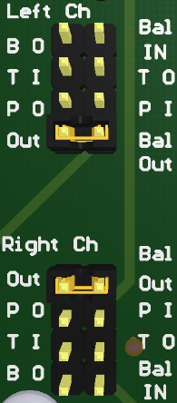

Figure 9 - Speaker Enable

You have been assigned a specific lab bench and stereo kit. You are responsible for them throughout the semester. Since this is the first lab in which you use equipment from the drawer, you will have to pass-off a clean, organized station at the end of this lab. Every station’s top drawer has a black organizer with 7 slots and pictures of what goes where as shown in Figure 10. If any of the items are missing, you must make note of it and notify an assistant at the time of sign-off, or in your Lab Report. Although you will not be required to pass-off the station in the future, you may still be deducted points if your station or equipment state is unacceptable. Consider this pass-off as an oportunity to strengthen your sense of responsibility and stewardship over the sacred resources we have available on this campus. INCLUDE A PICTURE OF YOUR LAB BENCH, THE INSIDE OF THE DRAWER, AND THE LAB KIT HOLDING THE SPEAKERS. If you are doing these labs remotely, take a picture of your put-away lab kit, soldering kit, and any other materials sent to you. Any lost equipment may be charged to you at the end of the semester.

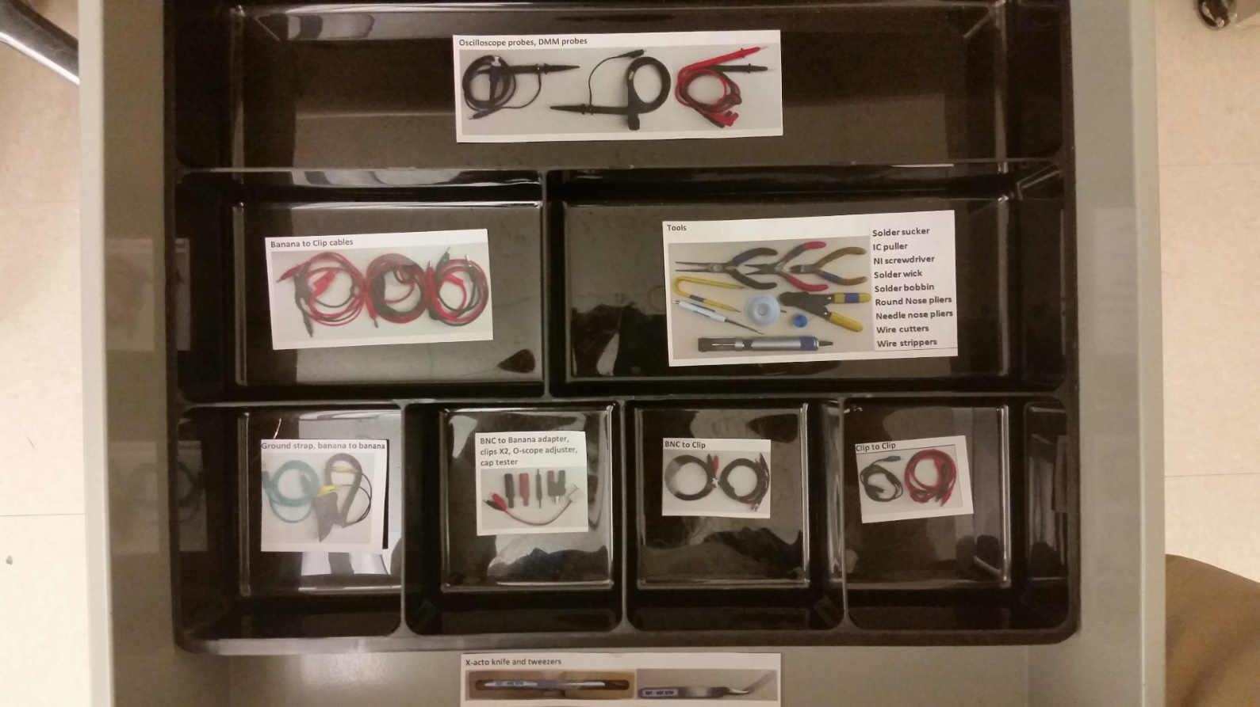

Figure 10 – Station Drawer Organization

# Lab Report

Your lab report should focus on the physical measurements you took in the lab, centered on Table 1, and interpret what they mean. But do remember to briefly comment about any screenshots included (they should be properly labeled and referenced) and about anything that was marked red or highlighted in green in the instructions. In your conclusions, indicate what issues you ran into and how you were able to overcome/fix those issues. Include things you learned in the design process. Also include a summary of the design specifications, if they were met or not, and why. If they were not met, what would you do (if you had the resources) to meet the design specifications. The grading rubric is shown below and on I-Learn.

|  |  |
| --- | --- |
| **Grading Rubric** | |
| **Worth** | **Description** |
| 5 | Lab report format (see I-Learn) |
| 5 | Potentiometer research |
| 25 | Design specifications met (tables, oscilloscope figures, and deviation equation) |
| 15 | Conclusion: Were design specifications met? |
| 35+5 | 35pts ->Working circuit (5pts -> recording passed off) |
| 10 | Organized drawer picture |
| **100** | **Total** |